Google Spreadsheets
Quick Start Guide
There are different ways of getting started using Google Spreadsheets: you can create a new online spreadsheet, you can upload an existing one, or you can use a template from the templates gallery.

Creating and saving a spreadsheet
To create a new spreadsheet, go to your Docs list, click the Create new drop-down menu, and select Spreadsheet.
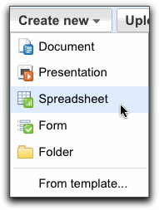
Click the Save button in the top right corner of the spreadsheet, enter a name for the spreadsheet in the window that appears, and click OK. When your spreadsheet is saved, it will appear in your Docs list.
Auto-save: Google Docs auto-saves your spreadsheet multiple times each minute. The time when the spreadsheet was last saved is shown in the top right corner of the screen.
If you'd like to save and close a newly created spreadsheet, click the File button and select Save and close from the drop-down menu.
To save a local copy of a spreadsheet, you can download it to your U:\ drive folder. To do this, open your spreadsheet, click the File menu and point your mouse to the Download as option. You'll see these file types: .csv, .html, .ods, .pdf, .xls, .txt. Select a file type for download, then click OK in the browser window that appears.

Uploading a spreadsheet
You can upload an existing spreadsheet to Google Spreadsheets at any time. Here's how:
- Click the Upload button at the top of the sidebar in your Docs list page.
- Click Browse and select the spreadsheet.
- Click Open.
- Click Upload File. The uploaded file appears in your Docs list.
- File types you can upload: .xls, .ods, .csv, .tsv, .txt, .tsb
- Size limits: Each spreadsheet can be up to 256 columns, 200,000 cells, or 100 sheets--whichever is reached first. There's no limit on rows.

Templates gallery
If you want to quickly create a spreadsheet, and would like some help, you can pick one of the templates in the templates gallery. Each template has text that you can replace with your own, and formatting that you can reuse.
You can also access the templates gallery from your spreadsheet by going to File > New > From template...

Editing cells
To enter content in an empty cell, just click the cell and add your content. To edit a cell that already has content, follow these steps:
- Choose one of the options below to place the cursor in the cell:
  - Double-click the cell.
  - Click the cell and press Enter.
  - Click the cell and press F2.
- Edit the cell's content.

Formatting your data
You can format data in your spreadsheets in a variety of ways. You'll find the formatting options on the Edit toolbar.
Adding formulas
To add formulas to your spreadsheets, follow these instructions:
- Double-click an empty cell.
- Click the Formulas button on the toolbar.
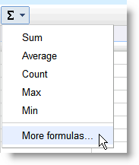
- Select a formula from the list, and the formula is inserted into the selected cell. Click the More formulas... link to see additional formulas.
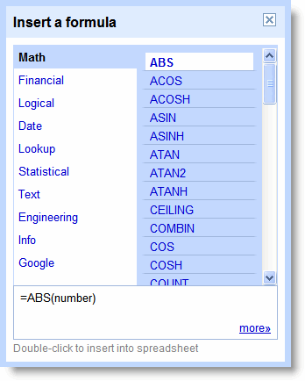
- Enter the symbols and attributes to see the formula computation.
Check a list of current functions.

Sharing your spreadsheets
Now that you've created your Google Spreadsheet, you can share it with your teacher and classmates. You can do this from your Docs list or directly from the spreadsheet.
- From the Docs list, select the checkbox next to the item you want to share (you can also select multiple spreadsheets), and click the Share drop-down menu in the toolbar. Then select 'Sharing settings.'
- From your spreadsheet, click Share in the top right corner of the page.
Then follow these instructions:
- At the bottom of the 'Sharing settings' window, under 'Add people,' type the email addresses of people you want to share your spreadsheet with. You can add a single person or a mailing list. You can also choose from a list of your contacts.
- To the right of the list of names, select 'Can view' or 'Can edit' from the drop-down menu.
- If you'd like to add a message to your invitation, enter some text and click Share. To skip sending an invitation, deselect the option 'Send email notifications (recommended).' Your collaborators and viewers will still be able to access the spreadsheet from their Docs lists, but won't receive an email invitation.
In the 'Sharing settings' window, you can also see who has access to your spreadsheet, change
how much access people have, remove editors and viewers, and
change your spreadsheet's visibility option.

- You can explicitly share your spreadsheet with up to 200 combined viewers and collaborators; however, if you publish your spreadsheet, anyone will be able to access it.
- Up to 50 people may simultaneously edit and/or view a spreadsheet

Simultaneous editing and viewing
If multiple people are editing or viewing the same spreadsheet at the same time, you'll see right below the Share drop-down menu the names of those who opened the spreadsheet. Click the arrows to the right of the names to start chatting with viewers or collaborators about changes you're making.
Gadgets
You can insert gadgets to display your spreadsheet data in a more visual way. From your spreadsheet, simply select Insert > Gadget. Then, the Add a Gadget window appears, where you can select gadgets in a number of categories, including charts, tables, and maps. Click Add to your spreadsheet to insert a gadget. Below are two examples of Google gadgets you can add.

Motion chart
If you're tracking several data points to see changes over time, you can create an interactive Motion Chart. Here's an example:
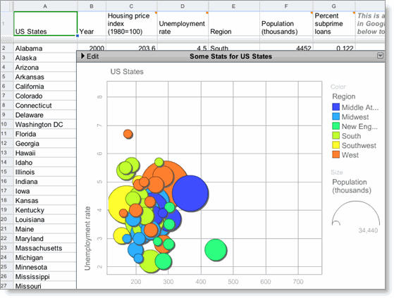

- In several columns of a spreadsheet, add the data (including column headings) for your chart. You'll need to create columns for the main data point, the time period, and two additional numeric values.
- Highlight the cells where you entered data in step 1.
- Go to Insert > Gadget.
- In the Add a Gadget window, scroll to Motion Chart and click the Add to your spreadsheet button.
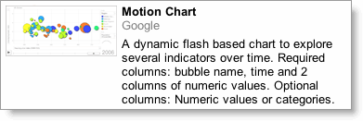
- The gadget menu appears in your spreadsheet. In the 'Range' field, enter the cell names where you added data in step 1.
- In the 'Title' field, create a title for your chart.
- Click Apply. The chart appears in your spreadsheet.
If you change any of the data relevant to this chart in your spreadsheet, the chart will update automatically. You don't need to repeat the steps above to edit the chart.

Heatmap gadget
The Heatmap gadget displays a map with color intensities based on values you add to your spreadsheet, including country ISO (International Organization for Standardization) codes and data you want to show. Here's an example:
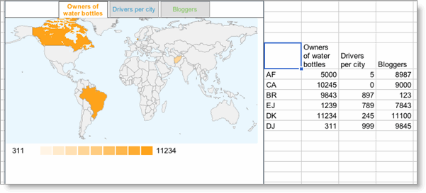
- In one column of your spreadsheet, enter the relevant country ISO codes (you can see a full list at the ISO website).
- In the adjacent column(s), enter the data you want to show.
- Highlight the cells where you entered data in steps 1 and 2.
- Go to Insert > Gadget.
- In the Add a Gadget window, scroll to Heatmap and click the Add to your spreadsheet button.
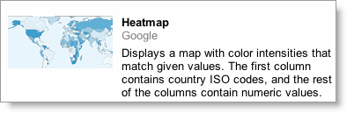
- The gadget menu appears in your spreadsheet. In the 'Range' field, enter the column names where you added data in step 1.
- In the 'Title' field, create a title for the gadget.
- Click Apply. The gadget appears in your spreadsheet.
If you change any of the data relevant to this chart in your spreadsheet, the chart will update automatically. You don't need to repeat the steps above to edit this chart.

